# MINI PROJECT

**TalkOn – Bringing the World Closer**

**MID-TERM REPORT**



**Institute of Engineering & Technology**

**Submitted by-**

Abhinandan Padmakar Pandey (181500008)

Harshit Pandey (181500256)

Harshit Arya (181500251)

**Supervised By*: -*** Mr. Vaibhav Diwan **(**Technical Trainer)

# Department of Computer Engineering & Applications

**Contents**



1. **Introduction 3**
   1. General Introduction to topic **3**
   2. Hardware Requirements **3**
   3. Software Requirement **3**
2. **Problem Statement 4**
3. **Objectives 5**

4**. Implementation Details 5**

1. **Screenshots 9**

# Introduction

# 1.1 General Introduction to topic

We are going to create an android social media application known as *Talkon*. We choose the Android platform because it is easy to access and available everywhere. The application is a chatting based application. In this application, the users can log in through the Google account. It will be like Facebook or Instagram. For connection, the application to google and login with google id we will use google API. We will also connect our android application *Talkon* to the database as there is a feature of sharing photos. For that, we will use the *Google Firebase* database. Why only Firebase? Why not others? The reason is that Google Firebase is one of the best open Google databases and it also provides lots of facilities like it supports APIs and Machine Learning tools. It will be a good choice. The looks of our application will be inspired by other popular social media applications like Facebook, Instagram, etc. From this application, we can communicate through chat with friends. We can add friends as well in this application. Well, it will help us understand the core concept of android development and java programming language. In this pandemic era of novel coronavirus when people are maintaining social distancing, a physical barrier is being created, this application could help people to come closer not physically but virtually.

From this application, we can communicate through chat with friends. We can add friends as well in this application. Well, it will help us understand the core concept of android development and java programming language. In this pandemic era of novel coronavirus when people are maintaining social distancing, a physical barrier is being created, this application could help people to come closer not physically but virtually.

# 1.2 Hardware Requirements

* Android Operating System
* Min 2GB RAM (Memory)

# 1.3 Software requirements

* Desktop or Smartphone
* Android Studio
* Internet Connection

**Problem Statement**

As we all knew that on 11 March 2020, WHO declared Novel Coronavirus Disease (COVID-19) outbreak as a pandemic and reiterated the call for countries to take immediate actions and scale up the response to treat, detect and reduce transmission to save people’s lives. In this regard, on 24 March 2020, the Government of India under Prime Minister [Narendra Modi](https://en.wikipedia.org/wiki/Narendra_Modi) ordered a nationwide lockdown for 21 days. Due to the lockdown and social distancing, a physical barrier is being created. So, we need a MADE IN INDIA method to interact with society as well as maintain the protocols of lockdown.

# Objective

To solve this problem we are going to create a MADE IN INDIA social media application and we will call it TalkOn. Our application *Talkon* will be able to provide the following features to the users, which are

* Login/signup using Google
* Search your friends
* Post your photos
* Like your friend’s photos

# Implementation Details

Here are some use-case diagramfor explaining the implementation of our application.

* Account Maintenance

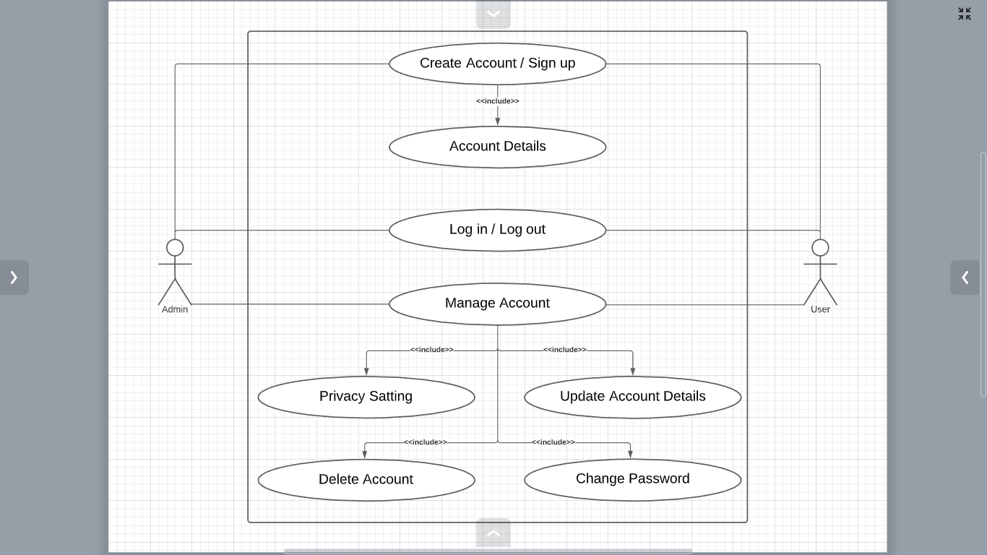

* Profile Management

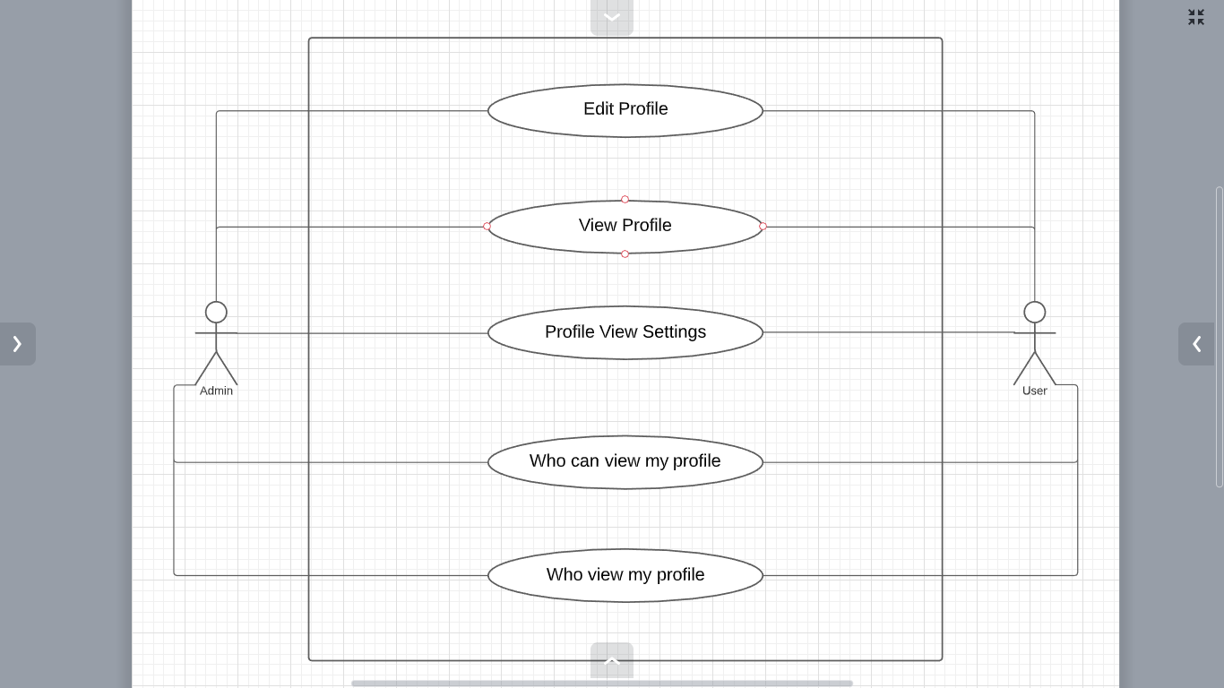

* Friend Management

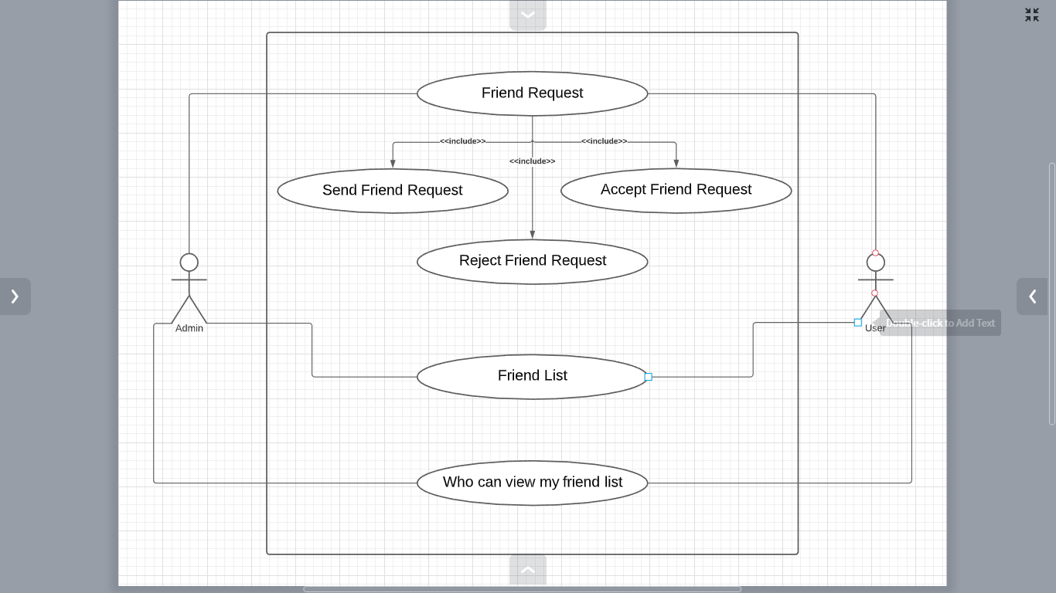

* Search Management

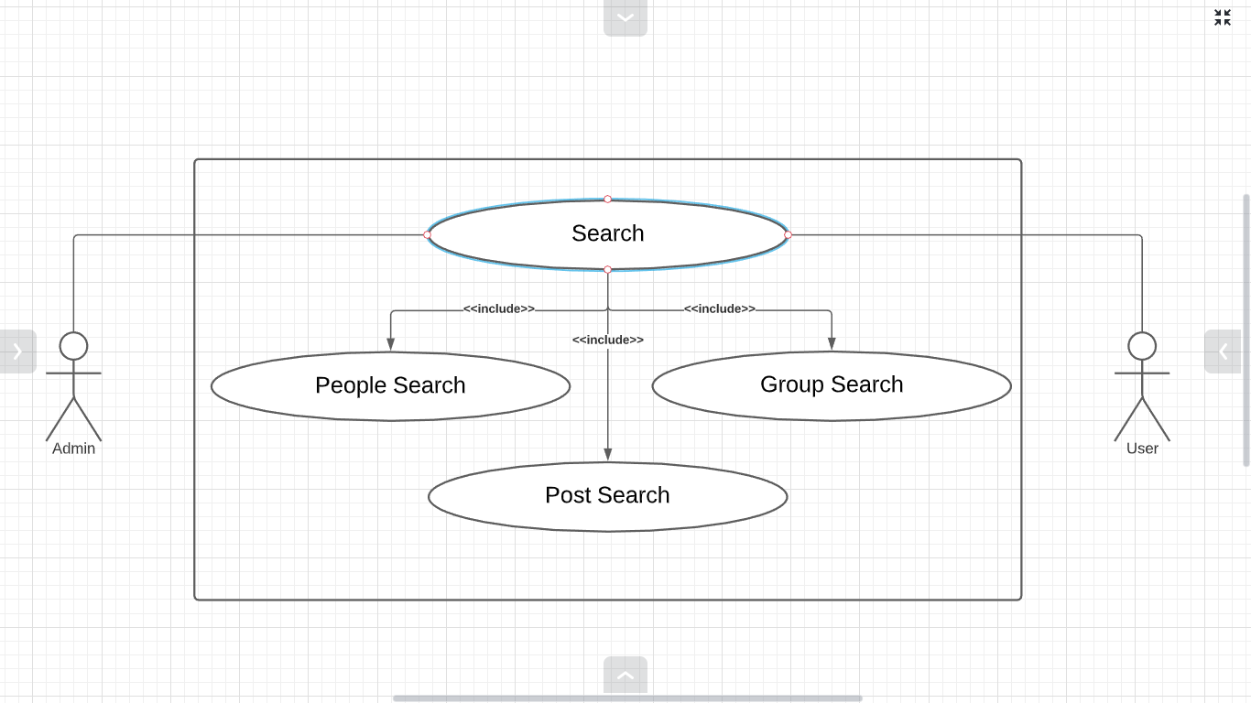

* Chat Management

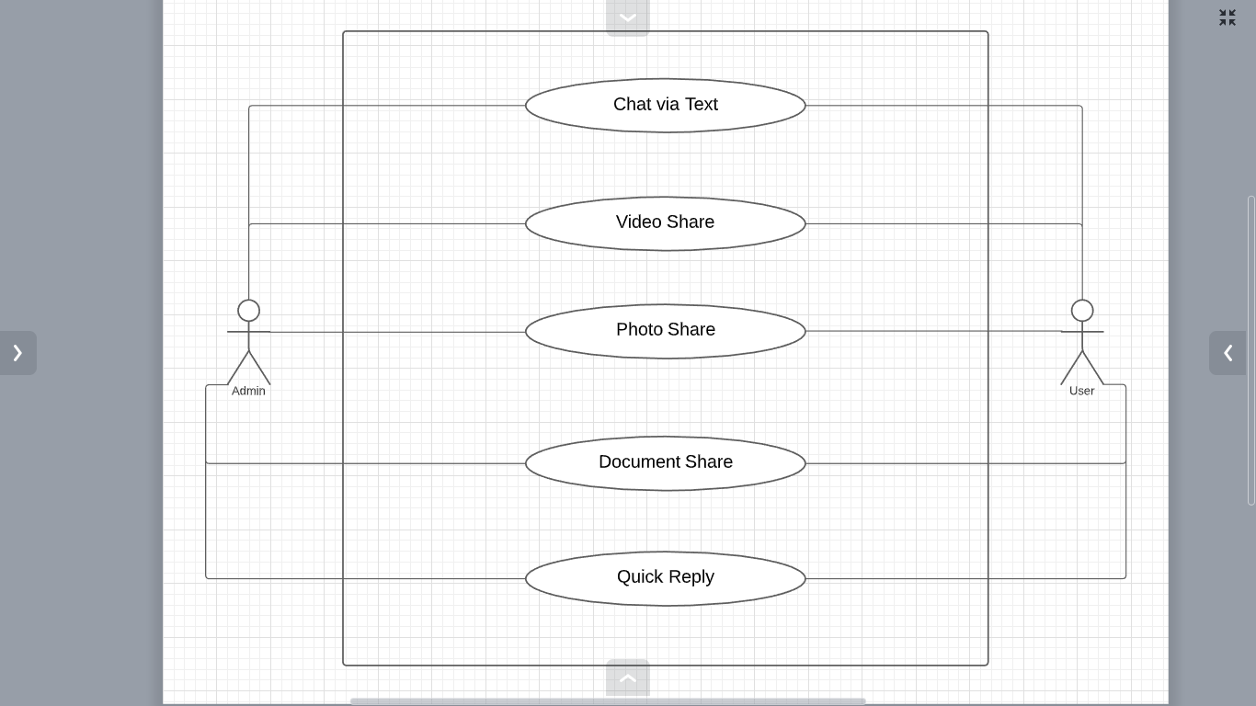

* Post Management

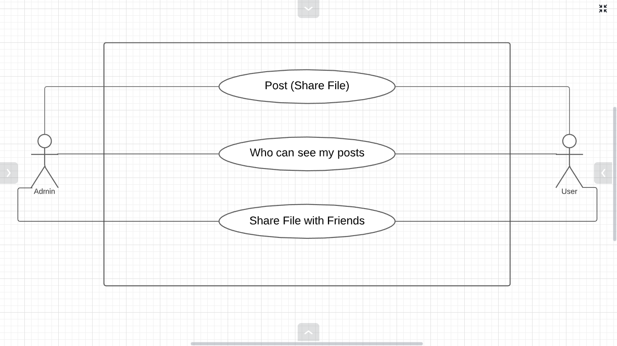

# Screenshot

